Practical no 7

Implement FOSS-Cloud Functionality VSI (Virtual Server Infrastructure)
Infrastructure as a Service (IaaS), Storage
Installing FOSS cloud on vmware

Choose disk to install (default is sda)

Fc-node-configuration -n demo-system --password admin

Ifconfig to get inet ip address

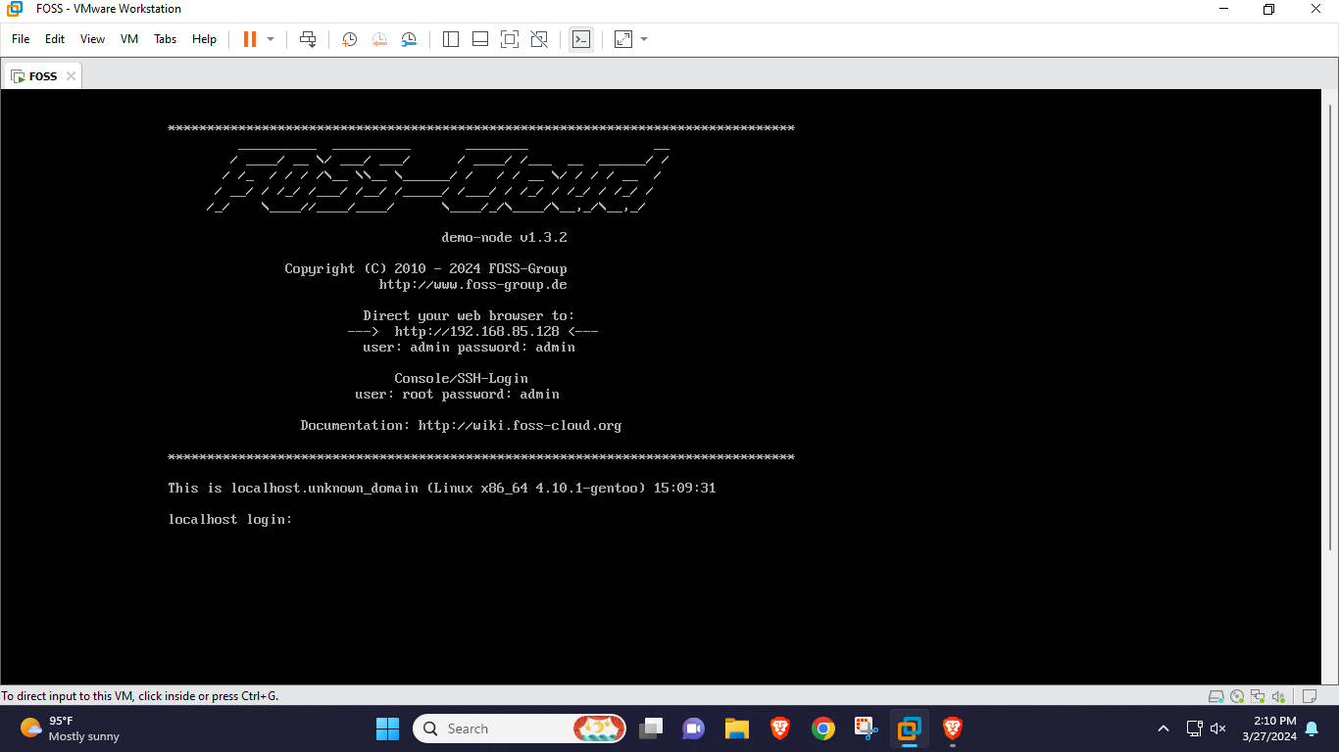

Modifying registry information for virtualization:

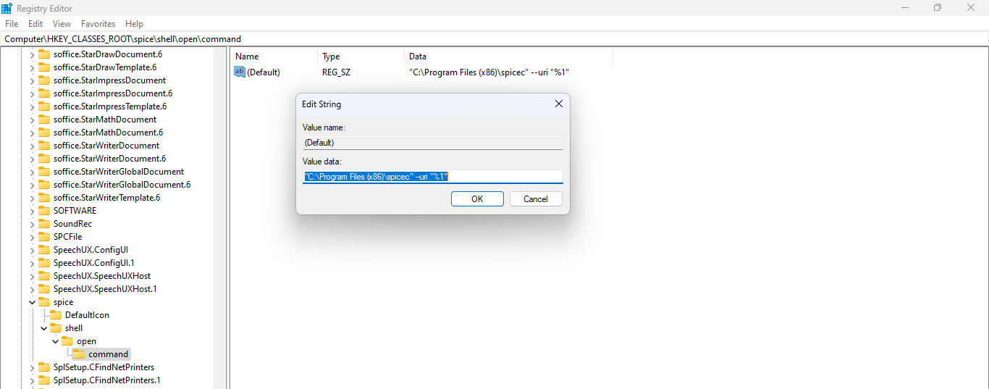

Accessing FOSS cloud through web browser:

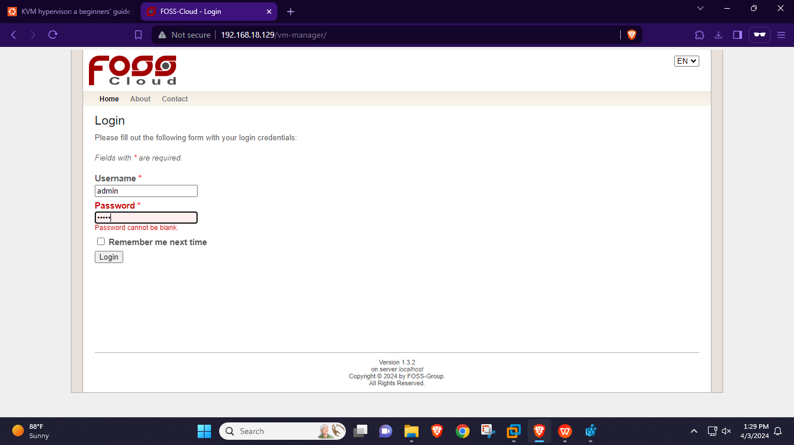

Uploading ubantu file:

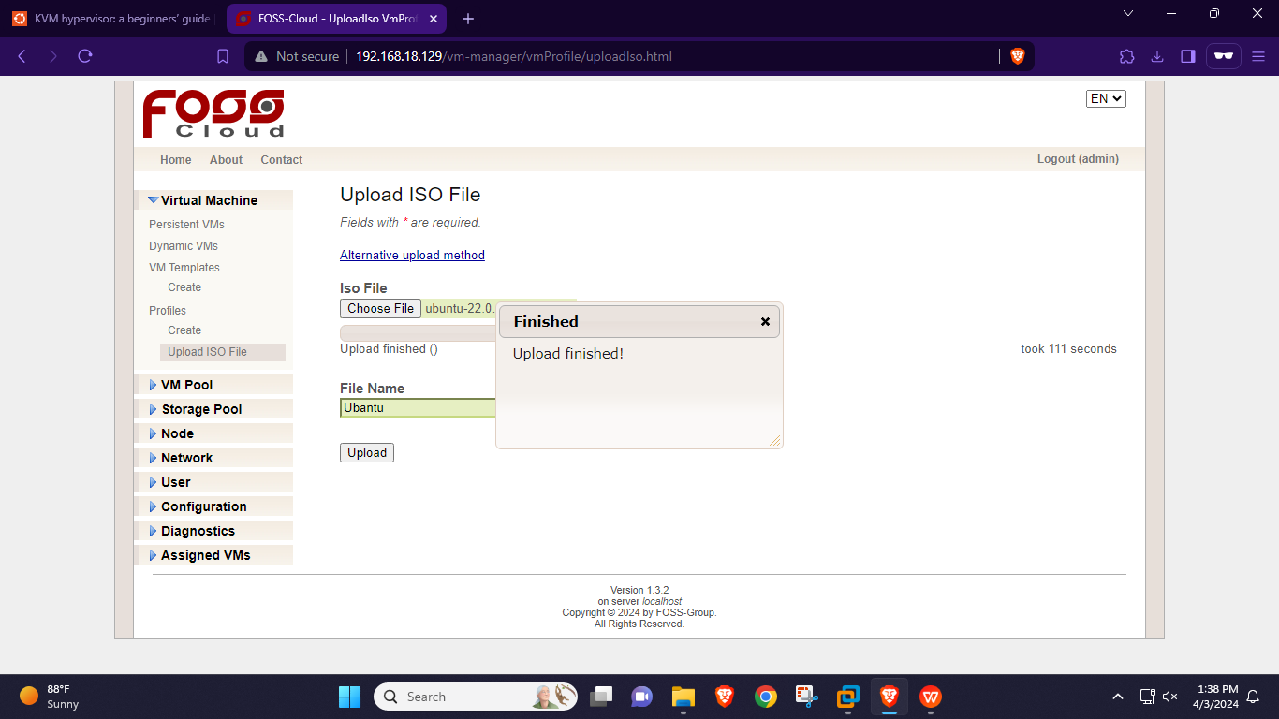

Creating VM template

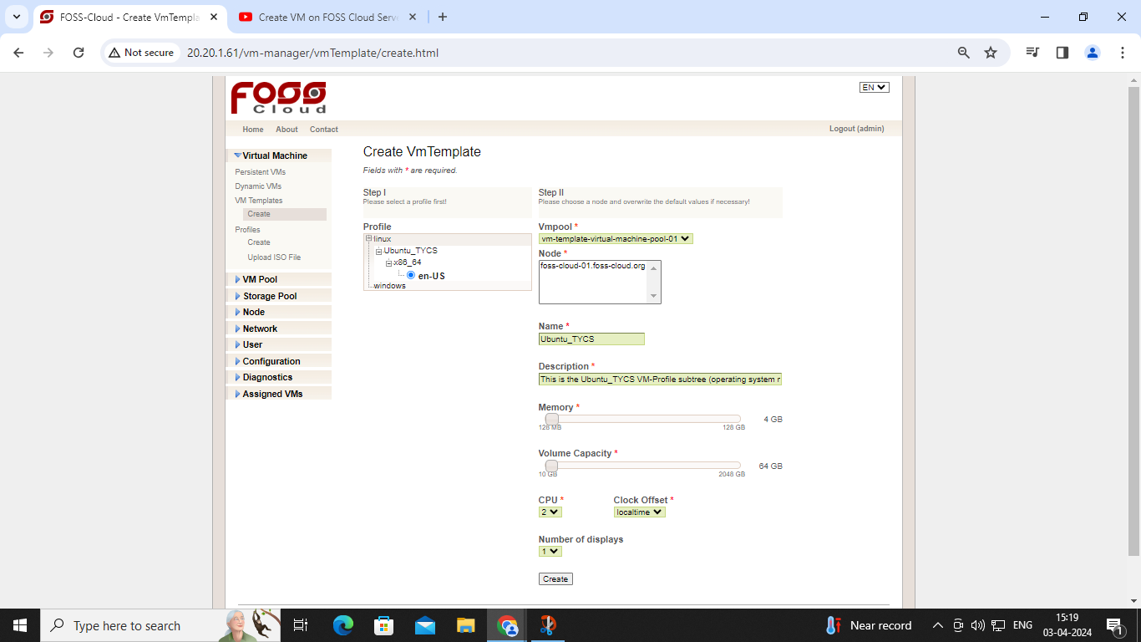

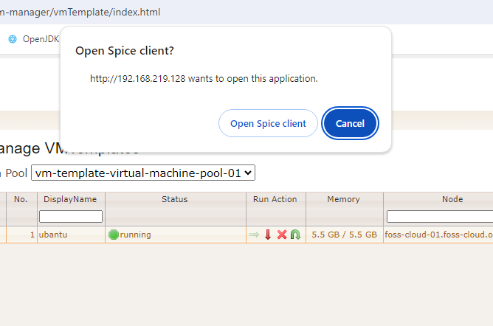

Accessing VM template

